Course Outline

Part 1: SCIENTIFIC WRITING AND PROFESSIONAL INSERTION

Chapter 1: INTRODUCTION TO SCIENTIFIC WRITING

Chapter 2: PROFESSIONAL INTEGRATION AND SPECIFICATION

Part 2: SCIENTIFIC WRITING AND VALIDATION

Chapter 3: WRITING AN INTERNSHIP REPORT CONTENT

Chapter 4: VALIDATION OF AN INTERNSHIP REPORT CONTENT

# PART 1: SCIENTIFIC WRITING AND PROFESSIONAL INSERTION

## CHAPTER 1: INTRODUCTION TO SCIENTIFIC WRITING

At the end of this course, the student should be able to:

* Know what a scientific document is
* Know the types of scientific documents
* Tell the difference between an internship report and a dissertation
* Know the techniques of scientific writing
* Know the procedure to submit an article in a scientific journal
* Know the method of writing a scientific article

The Writing of a 2nd year internship report at AICS CAMEROON usually requires a 3 months academic internship in a company. This document must be written in accordance with a certain outline set out in the specification book. Like any scientific documents. The student is asked to research a problem in the company through an internship theme in order to find the solutions to the problem. The aim of this course is to encourage the students to prepare their future academic internship. By doing so, they must reassure themselves that the quality of the document produced matches with the specification book. As well as preparing their defense project in front of the Jury provided for. But before discussing the drafting of an internship report, it will be interesting to look at the drafting of a scientific document in general

What is a Scientific Document?

It is a document that resolve the original research of the report. It is written and published by its author according to some scientific constraints. It is written for an audience of experts and reviewed by an independent reading committee to provide strong, sincere criticism and offer scientific and technical guardiance. One is often allowed to write a scientific document after much research in the laboratory or in the field.

DIFFERENCES BETWEEN A DISSERTATION, A THESIS AND AN INTERNSHIP REPORT

AICS CAMEROON students are admitted in an academic internship from the 1st of July to the 30th of September each year. At the end of this internship, they must produce an internship report and not a dissertation. The internship report is a document in which the student describes only the tasks performed in the company. In this document, he actually makes a triple review, which is the company that welcomed him, the work that was done there and the experience gained there.

A dissertation is mostly a research topic which is not related to the company but also deals with subjects that correspond to social problems which can be in the city, in the region or even more. The purpose of a dissertation is to explore an area of knowledge to analyse it and draw original reflections from it. The topics of dissertation are often for the Masters Level while those of internship reports are for Lower Levels. A dissertation prepares the work of a future thesis.

A thesis is an opinion or position of a speaker with respect to the subject or theme he evokes. Just like a dissertation or an internship report it is coordinated by a supervisor called a Thesis Director and then validated at the end of the work by a jury for a Doctorate.

A dissertation or thesis is an initiation into research which requires personal input. The doctorate student or master student is therefore required to carry out designed work and not a simple compilation as admitted to a certain extent in an internship report. This work should allow the student to acquire a critical sense and a spirit of synthesis.

TYPES OF SCIENTIFIC DOCUMENTS

It should be noted that a document is said to scientific when it deals with a subject in a scientific or technical field. A distinction is made between a research article, a review article and a research note.

A research article presents the original results of a research i.e. it presents new and original scientific findings and explain the research methodology and provides data.

The review article or an article of synthesis is based first of all on good documentary research. Its objective is to take advantage of another research, knowledge or conclusion in a specific film and draw up analysis or conclusions that can be exploited.

Research notes are not fully academic papers but are discussion notes seeking to advance in new ideas, a theoretical perspective, a research program or methodological approach in studies.

Writing an article or a scientific paper requires a number of constraints and specificities. It is composed to respect the 4 steps of an article or a research report.

* A problematic that contains the foundation of the scientific problem.
* The choice of an appropriate method to solve the problem.
* Analysis of the statistics of the data obtained during this research.
* Interpretation of results

After defining the problem, it is necessary to establish a work plan. The plan of scientific article has the following parts: the title, the abstract, the introduction, materials and methods, results, discussion, conclusion, acknowledgements, references (bibliography and webography).

Each scientific document has its own standard of writing which the author explains but which doesn’t leave the way the normal standard requires.

SOME STANDARD DRAFTING CONSTRAINTS

1. As in any document, formatting is required i.e. respect for punctuation, indentation (shifting the beginning of the first line of a chapter or paragraph), text alignments, tenses, correction of grammatical or spelling errors.
2. All that has been written in the document must be able to be explained by the author.
3. All notices must be clearly justified.
4. A dissertation or a thesis is a work of initiation to research which requires a personal contribution. The student is therefore required to carry out a designed work and not a simple copy and paste as admitted to a certain extent in an internship report. This work must allow the student to acquire a critical sense and a synthesis
5. Avoid writing full names of authors in the text when citing references but let it appear in the bibliography.
6. When quoting an author, the portion of the text quoted is enclosed in quotation marks and italics.
7. Any schema or figure must be followed by a legend placed below and its references.
8. With the use of tables in a document clearly expresses what you want to explain and it must have a legend placed above it.
9. The abstract of the document is always in English and in French.
10. References are cited in details in the references section. All the words quoted in the text are mentioned at the level of the references. Generally, references are quoted in this order: Name of the author, title of the article or book, name of the publisher, date published and number of pages.
11. The annexes are placed at the end of the document.
12. Like the annexes, the postface is also placed at the end of the document. It is time to humble recognising that all human work is not perfect.

SUBMITTING AN ARTICLE IN A SCIENTIFIC JOURNAL

A scientific journal is a periodical publication intended to further the frequence of science usually by importing recent resources. Articles in scientific journal are mostly written by active scientist such as students, researchers and professors instead of professional journalist. Before submitting this article, the author must ensure that he has complied with the author’s guide and that the article is well suited to the journal. To submit an article, this can be done by a classical (physical) or electronic form accompanied by a letter of submission. This letter presents the strength and originality of the submitted article. The research mainly concerns the field of the journal, originality, respect of author’s guide, bibliography and scientific quality. The decision of acceptance or rejection can be strongly influenced by the different comments of the readers.

CHAPTER 2: PROFESSIONAL INTEGRATION AND SPECIFICATIONS

At the end of this part, the student must be able to

* Know how to integrate professionally into a company.
* Know how to write CV.
* Understand in details or the context of the specification book that the school makes available to them.
* Know how to write the terms of reference of this internship report.

Professional integration is an important step in the development of an academic internship.

This internship is framed by a specification book that the student is required to respect to avoid going away from expectations. The aim of this part, is to facilitate the professional integration of the student during his internship period and give guidance in the drafting of the specification of the topics he will deal with in the company.

PROFESSIONAL INTEGRATION

It should be remembered that an internship although it is academic is a service that is rendered to the company over a short period of time. It is a job like any other professional activity when you perform an academic internship in a company you are somehow in a job situation. It may or may not be renumerated. It all depends on the status of the company. The student is thus immersed in professional environment that is different from the academic environment for which he has to adapt.

LOOKING FOR AN INTERNSHIP

1. Responsibility of the student:

It is the responsibility of the student to look for a company where he or she will carry out the internship. This research for an internship site, should be carried out 3 to 4 months before the beginning of the official period which is from the 1st July to 30th September of the academic year. For companies that ask for recommendation letters, the school can issue letters of recommendation to them which constitutes a major support for the student.

1. Responsibility of the School:

AICS Cameroun facilitates access to academic internship through some agreements signed with certain complements. The best students are most often privileged

1. How to look for an internship:

The choice of the company where one wishes to carry out the academic internship first concerns its legal existence and its basic activity. The company must be able to provide you with tasks related to the IT field. Access to an internship is done in the same way as a job. We target the place for an academic internship accompanied by CV, a motivation letter, a school attendance certificate and a recommendation letter signed by the resident representative if necessary.

A student can also get an academic internship through another way using his own facilities.

1. Writing a CV

CV stands for Curriculum Vitae which is a document that describes who we are, what our skills and values are and us know how. A CV is written strategically with the objective of hooking the attention of the employer to choose you among others. You have to customize a CV according to the offer. One should avoid using the same CV for several job offers since the motivations and offers may differ from one company to another. In general, the elements of a CV constitute the name and address of a candidate, the training, the professional experience, the language or languages spoken and written, the hobbies.

1. Writing a CV:

Since student do not yet have a certain experience in a particular domain it is important for them to insist on the diploma acquired and on the trainings. Show your team spirit, your sense of organisation and your ability to follow instructions.

1. Writing a CV for a job

For a job a CV is written emphasizing on a work experience, training acquired and language.

SUCCESSFUL INTERGRATION

When a student is admitted in a company, he or she is now a member of the professional family of the company until the end of the internship. He is subject to the rules common the category of personnel to which he is attached. For a better professional integration, a student must do a positive contribution of his or her skills and know how. It is important to know the names of your supervisors and co-workers.

Exercise: Write an application letter for an internship in a local company of your choice.

NOUBISSIE SOH

DRIANE LAURIE

AWAE-YAOUNDE

laurienoubissie@gmail

[Tel: 691366621](Tel:691366621)

Friday 31st Jan 2025

AN APPLICATION FOR AN ACADEMIC INTERNSHIP

THE CHIEF EXECUTIVE OFFICER OF HITECH SARL

DAMAS-YAOUNDE

Dear Sir/Madam,

It is with immense interest that I write to your highly esteemed personality to apply for an academic internship in your prestigious enterprise.

I am a 2nd year student of African Institute of Computer Sciences in Yaoundé on pursue of a bachelor’s degree. Furthermore, I am versed with several skills like coding in PHP, JAVA, PYTHON and has a little mastery in REACT JS and DJANGO. Also, I am a very punctual and hardworking student and I believe that my moral conduct aligns with your standards. I promise to uphold to all expectations and keenly listen to your criticisms under your guidance.

On await for a favourable response, I thank you for your kind consideration.

Yours Sincerely,

S.L

Soh Laurie

Exercise 2 : Mr Ondoua Raymond is a second year student at AICS Cameroon he is of a Cameroonian nationality, he is single and he is 22 year olde of age with a height of 1m72. His 2 children are respectively 6 and 2 ye ars old. He did all his studies in Cameroon. He obtained his FSLC in 2009, at the highschool of Mbankomo he obtained his GCE(Ordinary level). He did the series A4 at Barrick College and obtained his GCE (Advanced level). He speaks and write English perfectly, French moderately and a little Chinese. Mr Ondoua is the president of the maintenance club. He enjoys travelling and reading. He is a respectful and calm young man. Previously he had done marketing and hotel managements in 2 training centres, EdenMark and Nadu Hotel respectively. He also practises this 2 activities in parallel with his studies at AICS. Mr Ondoua wishes to do an academic internship at E-Soft from the 1st of July to the 30th of September 2025.

Activity

Write his CV so that his application is selected among others.

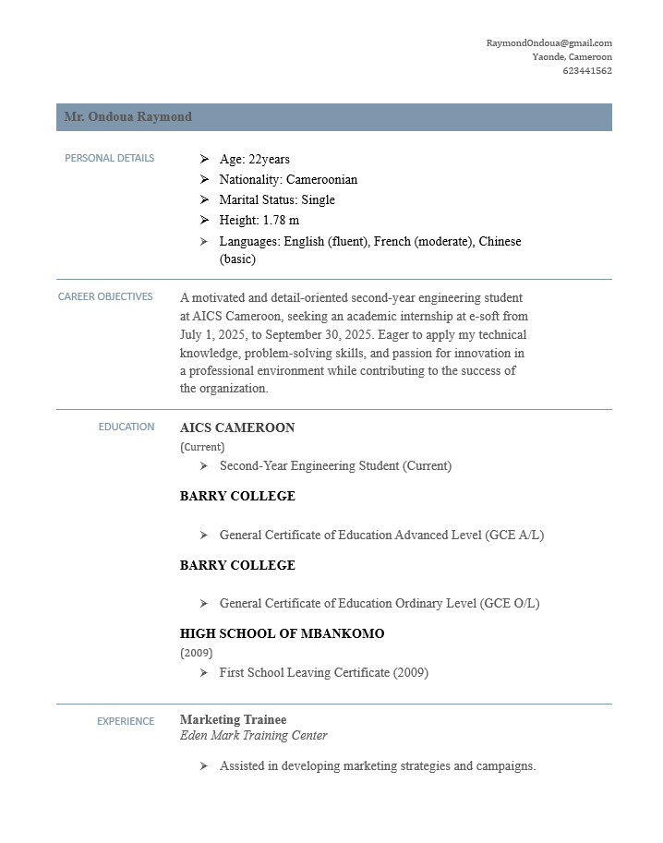

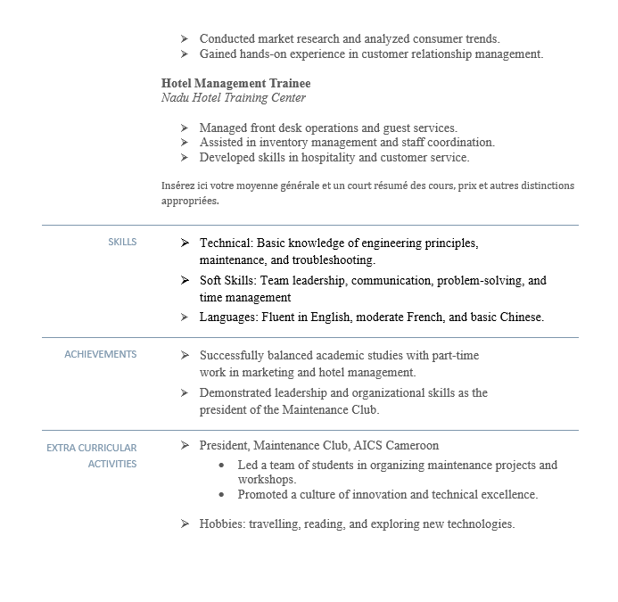

PS: Little mistake GCE O/L is form HIGH SCHOOL Of Mbankomo

GETTING STARTED

The beginning of the internship is marked by the welcoming. Upon arrival the student must first meet the head of department where he or she has been assigned. He will introduce him to his colleagues and assign him a professional supervisor who may be himself or someone else. The new trainee must be available, respectful, dynamic and humble. It is in his own interest. Reports of work related tot the topic of internship or other parallel classes must be frequent. A good student must observe the difficulties that the company faces and propose a solution

THE SPECIFICATION BOOK

This is a document that frames the students academic internships. Its specify the behaviour of the student during his internship.and in a particular the way he or she must write his report that is the organisation the planning, the monitoring of the work etc.

ORGANISATION

This is organised into 2 main parts. The integration phase and the technical phase

1. The insertion phase: It last for 2 weeks and it is the moment reserved for the student to discover his working environment i.e know his academic supervisor and his technical correspondence still called the trainee master (or commonly known as professional supervisor not to mention his other colleagues). The administrative supervisor is the one who deals with administrative aspect(absence and punctuality, exchange of documents in the school etc.). It is generally the supervisor of the trainee of the other. In other cases, it is the director of a company. To better intergrate the group, Kit is the right time for the trainee to show his or her knowledge and life skills. This is also a period :of the attribution of the internship theme; The supervisor will formulate a topic related to a crucial problem hat the company is experiencing and then assign it to the student so that the student can find a solution

ze